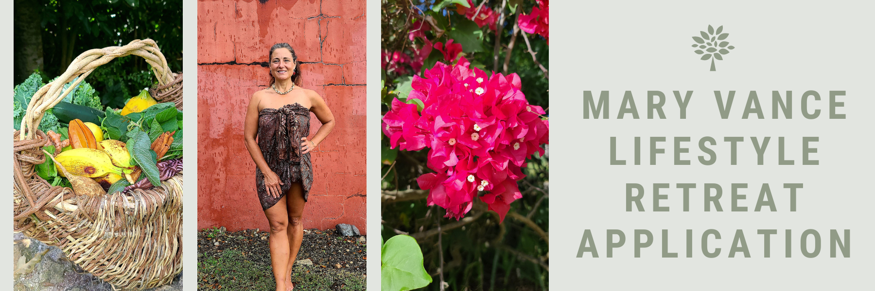
10 Day Lifestyle Habit Change
& Introspective Island Retreat Application

Mary Vance
Text or Call: 517-304-8066
www.maryvancelifestyle.com

Thank you for your dedication to personal transformation & willingness to invest in your life experience!

Name:

Birth Date with year:

Date:

Mailing address:

Email Address:

Phone number:

*** Please note that there is a separate intake that you will be filling out after your consultation with Mary that is primarily focused on your current nutritional habits, lifestyle patterns, and goals. ***

What do you desire to achieve or gain from this 10 day retreat experience? Please be HONEST and as specific as possible.

Are you looking for a ceremonial experience or vision quest within the retreat?

Are you interested in fasting/cleansing/detoxifying within this retreat?

Do you have any physical, mental, or emotional limitations that you need your retreat team to be aware of?

Do you have any specific needs that require special care that the retreat team will need to be aware of?

How many people will be coming with you on retreat?

